|  |  |
| --- | --- |
|  | TutorialOn  Gaba, Vince Harley, D.  He, Zhiyang  Manuel, Lester, N. |

1. Table of Contents

A Objectives 1

B Scope and Features 2

B.1 Scope and Feature # 1 2

B.2 Scope and Feature # 2 2

C Limitations 3

C.1 Limitation # 1 3

C.2 Limitation # 2 3

D System Requirements 4

D.1 Hardware Requirements 4

D.1.1 Processor 4

D.1.2 Memory 4

D.1.3 Storage 4

D.2 Software Requirements 4

D.2.1 Operating System 4

D.2.2 Software Requirements 4

E Class Diagram 5

E.1 {Name} Class Diagram 5

F Class Definition 6

F.1 {Name} Class Definition 6

G User Manual 8

G.1 Peer Adviser Login 8

G.2 Advisee Login 9

G.3 Administrator Login 11

H References 12

H.1 Reference # 1 12

H.2 Reference # 2 12

List of Figures

Figure F.1.a: {Name} Class Diagram 5

Figure G.1.a: Peer Adviser Login 8

Figure G.2.a: Advisee Login 9

Figure G.3.a: Administrator Login 11

# Objectives

{Objective Paragraph 1}

{Objective Paragraph 2}

{Objective Paragraph 3}

# Scope and Features

## Scope and Feature # 1

Scope and Feature # 1 details…

## Scope and Feature # 2

Scope and Feature # 2 details…

# Limitations

## Limitation # 1

Limitation to “Scope and Feature # 1” detail # 1

Limitation to “Scope and Feature # 1” detail # 2

## Limitation # 2

Limitation to “Scope and Feature # 2” detail # 1

Limitation to “Scope and Feature # 2” detail # 2

# System Requirements

## Hardware Requirements

### Processor

Processor Core Count : {Value}

### Memory

Memory Capacity : {Value} {Unit (e.g. GB)}

### Storage

Disk Size : {Value} {Unit (e.g. GB)}

## Software Requirements

### Operating System

Operating System Name : {Value}

Architecture Type : {Value}

Edition : {Value}

### Software Requirements

Software Application # 1 : {Value}

Software Application # 2 : {Value}

Software Application # 3 : {Value}

# Class Diagram

## {Name} Class Diagram

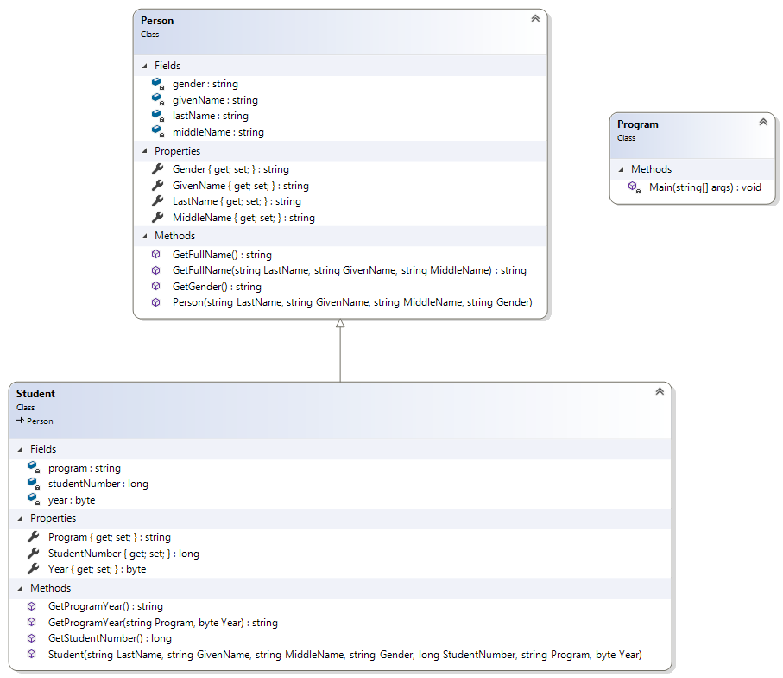

Figure .: {Name} Class Diagram

# Class Definition

## {Name} Class Definition

|  |  |
| --- | --- |
| **Name:** | Person |
| **Type:** | Class |
| **Description:** | Used to store and get person information. |
| **Fields:** | personID : int |
| name : string |
| **Properties:** | PersonID { get; set; } : int |
| Name { get; set; } : string |
| **Methods:** | Person(int PersonID, string Name) |
| GetID() : int |
| GetName(string LastName, string GivenName) : string |

|  |  |
| --- | --- |
| **Name:** | Person |
| **Member Name:** | Person |
| **Type:** | Constructor |
| **Description:** | Used as a constructor for the “Person” class. |
| **Parameters:** | int PersonID |
| string Name |
| **Return Value:** | None |
| **Return Type:** | None |

|  |  |
| --- | --- |
| **Name:** | Person |
| **Member Name:** | GetID |
| **Type:** | Method |
| **Description:** | Used to get ID of person. |
| **Parameters:** | None |
| **Return Value:** | ID |
| **Return Type:** | int |

|  |  |
| --- | --- |
| **Name:** | Person |
| **Member Name:** | GetFullName |
| **Type:** | Method |
| **Description:** | Used to get full name of person based from last and given name. |
| **Parameters:** | string LastName |
| string GivenName |
| **Return Value:** | Name |
| **Return Type:** | string |

|  |  |
| --- | --- |
| **Name:** | Student |
| **Type:** | Class |
| **Description:** | Used to store and get student information. |
| **Fields:** | program : string |
| studentNumber : long |
| year : byte |
| **Properties:** | Program { get; set; } : string |
| StudentNumber { get; set; } : long |
| Year { get; set; } : byte |
| **Methods:** | GetStudentNumber() |
| GetProgramYear(string Program, byte Year) : string |

|  |  |
| --- | --- |
| **Name:** | Student |
| **Member Name:** | Student |
| **Type:** | Constructor |
| **Description:** | Used as a constructor for the “Student” class. |
| **Parameters:** | string Program |
| long StudentNumber |
| byte Year |
| **Return Value:** | None |
| **Return Type:** | None |

|  |  |
| --- | --- |
| **Name:** | Student |
| **Member Name:** | GetStudentNumber |
| **Type:** | Method |
| **Description:** | Used to get student number of student. |
| **Parameters:** | None |
| **Return Value:** | StudentNumber |
| **Return Type:** | string |

|  |  |
| --- | --- |
| **Name:** | Student |
| **Member Name:** | GetProgramYear |
| **Type:** | Method |
| **Description:** | Used to get program and year level of student. |
| **Parameters:** | string Program |
| byte Year |
| **Return Value:** | ProgramYear |
| **Return Type:** | string |

# User Manual

## Peer Adviser Login

Enter student number (10-digit).

Click “Login”.

Enter password.

Click “Login”.

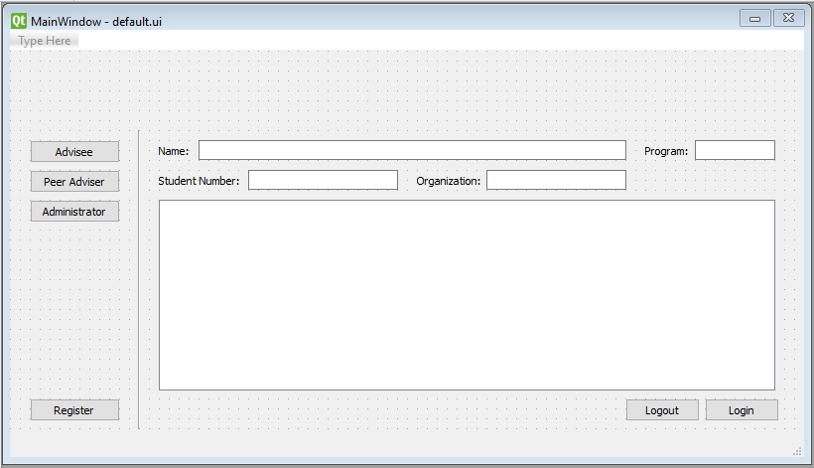

Figure .: Peer Adviser Login

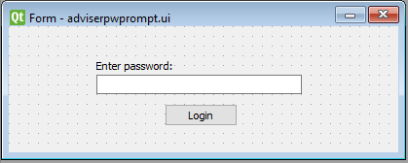

Figure .b: Peer Adviser Login Password Prompt

## Advisee Login

Enter student number (10-digit).

Choose a field (Mathematics, Chemistry, Physics, or Professional Course)

Select a course code from the drop-down list.

If “Others” is selected, enter the course code.

Click the “…” button to choose a peer adviser from the logged in list.

Select a peer adviser.

Click “OK”.

Click “Login”.

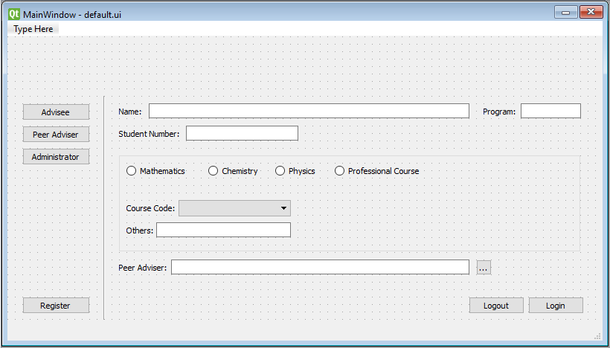

Figure .: Advisee Login

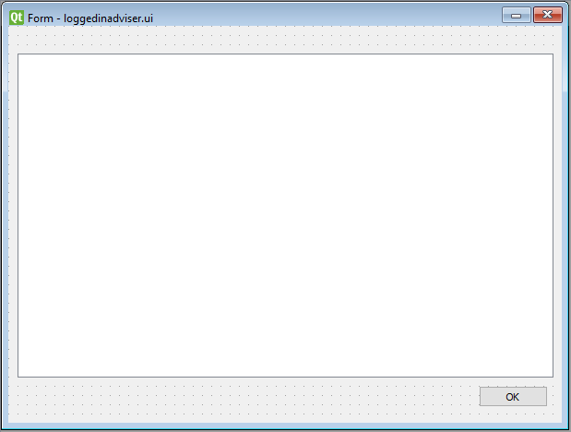

Figure 2.b: Logged-In Peer Advisers

## Administrator Login

Enter username.

Enter password.

Click “Login”.

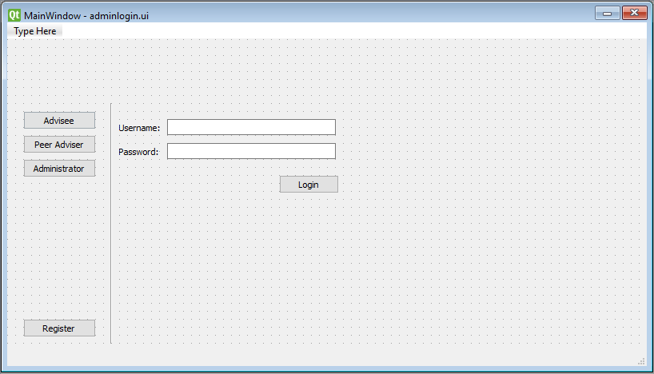

Figure .: Administrator Login

# References

## Reference # 1

Reference Title : {Value}

Reference Author : {Value}

Reference Page Source : {Value}

## Reference # 2

Reference Title : {Value}

Reference Author : {Value}

Reference Page Source : {Value}

